Midterm Exam (CSCI6339, Fall 2020)
Instructor: Dr. Bin Fu
Due 11:59pm Oct 15, 2020 (Thursday)

Name: Ulvi Bajarani

ID: 20539914

Problem 1 (25) Give state diagram of DFA recognizing L={w | w is 0,1-string, and contains 3k 0s and 2m 1s for some integers k and m at least 0}. For examples, 0010111 is in L, but 010011 is not in L. The first string contains 3 0s and 4=2x2 1s, but the second string has an odd number of 1s.

Answer 1

In the diagram below, the possible solution of DFA is designed:

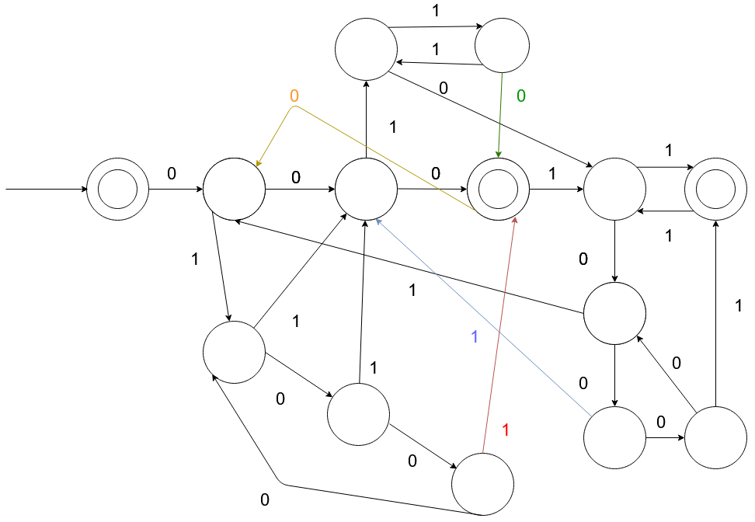

Problem 2 (25)
(a) Prove that the language L1={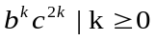} is not regular language with the pumping lemma.

(b) Prove that the language L2={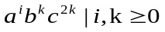} is not regular language with the pumping lemma.

Answer 2

a) To define if the language is regular, let’s have x = b^{k} , y = c^{k}, z = c^{k} . In this case, S and P might be b^{k}c^{k}c^{k} so that |S| ≥ |P| and |xy| ≤ |P|. Let’s pump it to xy²z = b^{k}c^{2k}c^{k} . In this case, the number of c in y is higher than in z. Since we should have an equal number of c in both y and z, we get the contradiction, so L1 is not a regular language.

b) To define if the language is regular, let’s have x = a^{i} , y = b^{k}c^{k}, z = c^{k} . In this case, S and P might be a^{i}b^{k}c^{k}c^{k} so that |S| ≥ |P| and |xy| ≤ |P|. Let’s pump it to xy²z = a^{i}b^{2k}c^{2k}c^{k} . In this case, the number of c in y is higher than in z. Since we should have an equal number of c in both y and z, we get the contradiction, so L2 is not a regular language.

Problem 3 (25) Prove that the language L={(M, N): M is a Turing machine and N is a DFA with L(M) =L(N)} is undecidable. You need to derive a reduction from Atm={(M, w)|Turing machine M accepts w} to L.

Answer 3.

Assume that L is decidable. Then, there is the decider Turing machine R such that:

a) giving accept if L(M) = L(N);
b) giving reject if L(M) ≠ L(N);

Define Turing machines M and DFA N, where

a) M accepts any input if A_{TM} returns accept;
b) N rejects all inputs;

Then define the Turing machine S with input <M> such that

1) Runs R on <M, N>.
2) If R gives accept, then S also gives accept. If R gives reject, then S also gives reject.

If the languages are equivalent, then M and N are empty. Otherwise, L(M) ≠ L(N); Since it is not possible to have a decider defining if the language is empty, we can assume that EQ_{TM} is undecidable. Let’s prove the last statement:

Design R’ for input <M> such that:

a) giving accept if L(M) is empty
b) giving reject if L(M) is not empty

Then, design S’ to decide A_{TM} such that

a) Constructs Machine M₁: if input ≠ w, M₁ rejects.
b) if input = w, run M on w and give accept if M accepts. It is possible only if L(M₁) = {w}.

Then run R’ on the input <M₁>
a) if R’ gives accept, S rejects
b) if R’ gives reject, S accepts

Since S’ gives accept if and only if L(M₁) ≠ Ø , we cannot say if A_{TM} halts on w/or accepts the w, so we get the contradiction.

Problem 4 (25). Derive one-one correspondence between the real numbers in (0,1) and the set of irrational numbers in (0,1). Hint: you need to use the fact that the set of rational numbers in (0,1) is countable.

Answer 4.

If we define q=a/b so that 0<q<1 and q ∈ Q, we can start to map. Let’s have the map from q to the real numbers in (0, 1). It might be done by the function

g(a/b) = 1/2ª3^{b}

Then, map the real numbers in (0,1) to the irrationals in (0,1). Knowing that π is irrational, we can define the function

h(a/b) = a / b*π.

Then, the composition

F = g ∘ h = g(h(a/b)) is the correspondence between the real numbers in (0,1) and the set of irrational numbers in (0, 1).

